|  |  |  |
| --- | --- | --- |
| Project Settings: <https://drive.google.com/open?id=1bIWSzxDlhNRyUOUX_9wq728ZlzKtD0T2mv1hEl6MYnA>  Please view project settings before start | | |

1. **Task Requirement / Description**
2. **Navigate to Task Area**
3. **UI Example**
4. **Programming Logic**
5. **Database**
6. **Changes to Commit ( developer to complete )**
   1. **Files / Folders to add to live site**
   2. **Database Changes to add to live site**
   3. **Developer notes / instructions for Project Manager**

**1. Task Requirement / Description**

Update contact us page to send email to [sales@merrimancontrols.com](mailto:sales@merrimancontrols.com)

Update text details on page

* Remove section “Get in Touch”
* Update Contact Details
  + U6, 10 Donaldson Street, North Wyong, NSW Australia
  + (02) 4351 4022
  + (02) 4351 4024
  + sales@merrimancontrols.com

**2. Navigate to Task Area**



**3. UI Example**

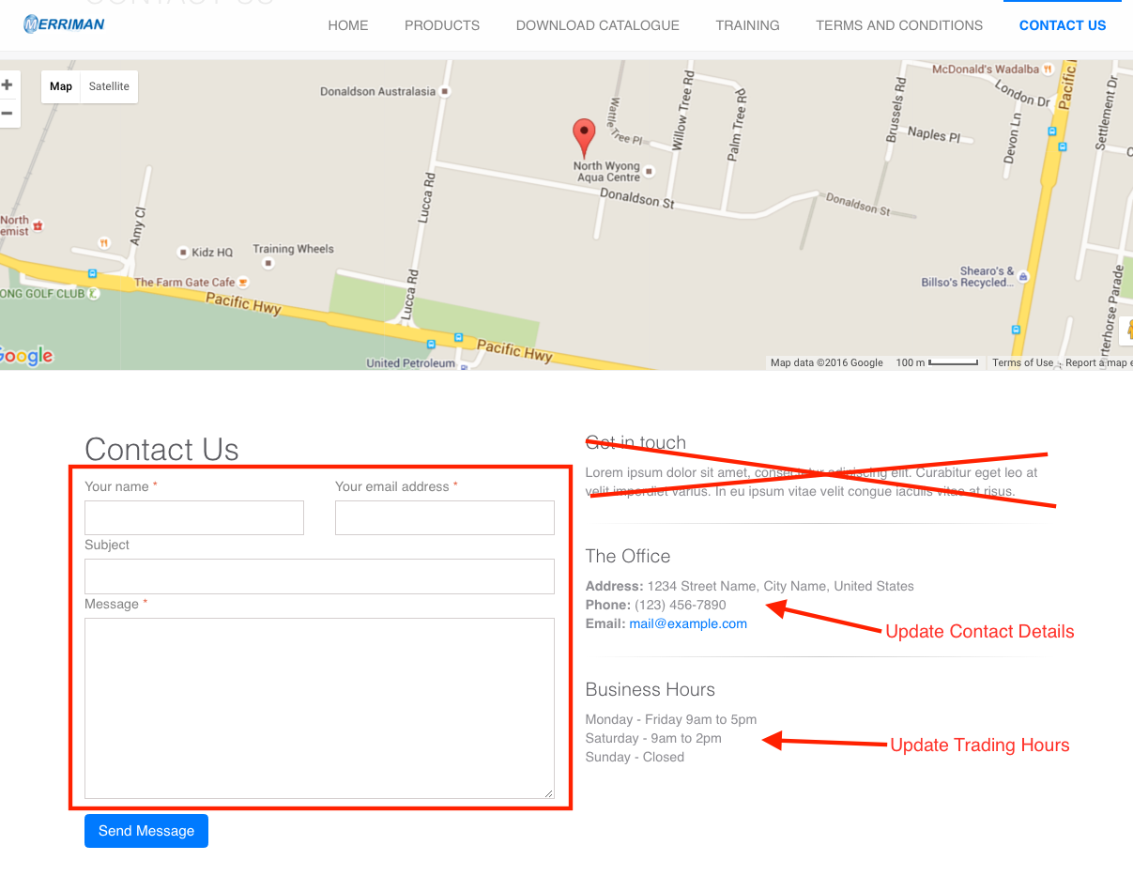

**4. Programming Logic**

When user click on “Send Message”

1. Validate form fields
   1. All fields required
   2. Check email address format
2. Send email to sales@merrimancontrols.com

**5. Database**

n/a

**6. Changes to Commit ( Developer to Complete section 6a, 6b, 6c)**

This section is to help the Project Manager update the test site and live site. Please fill in the below area’s 6a, 6b and 6c, this is to inform the Project Manager as to what changes were made and needed to add update the live site

**6a. Files / Folders to add to live site**

Please add to the below table a list of files or folders that the Project Manager will need to upload to the live site.

|  |  |  |  |
| --- | --- | --- | --- |
| Folder Name: |  | | |
| File Name | File Name | File Name | File Name |
|  |  |  |  |
|  |  |  |  |
|  |  |  |  |

|  |  |  |  |
| --- | --- | --- | --- |
| Folder Name: |  | | |
| File Name | File Name | File Name | File Name |
|  |  |  |  |
|  |  |  |  |
|  |  |  |  |

|  |  |  |  |
| --- | --- | --- | --- |
| Folder Name: |  | | |
| File Name | File Name | File Name | File Name |
|  |  |  |  |
|  |  |  |  |
|  |  |  |  |

**6b. Database Changes to add to live site**

Please add below any db changes or db script code the Project Manager will need to add to the live site database

1. Send email to sales@merrimancontrols.com

For this instruction

You need to change value in database

table settings type = system_email

Value = [sales@merrimancontrols.com](mailto:sales@merrimancontrols.com)

Script is sending contact us email to system_email

Hope this make sence

**6c. Developer notes / instructions for Project Manager**

Please add here any instructions for the Project Manager to follow for updating the live site

Eg. 1. Please run db script

2. Please insert new data to db

3. Then update files in live site

**END**